EXPERIMENT – 21
MYSQL String Functions- SPACE, SUBSTR, UPPER, LOWER, TRIM, LENGTH
SPACE, SUBSTR, UPPER, LOWER:

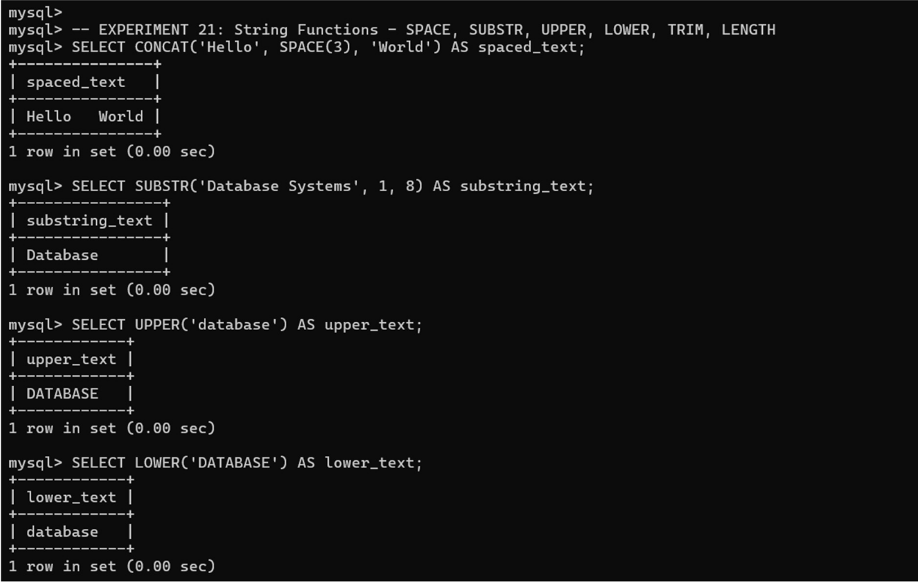

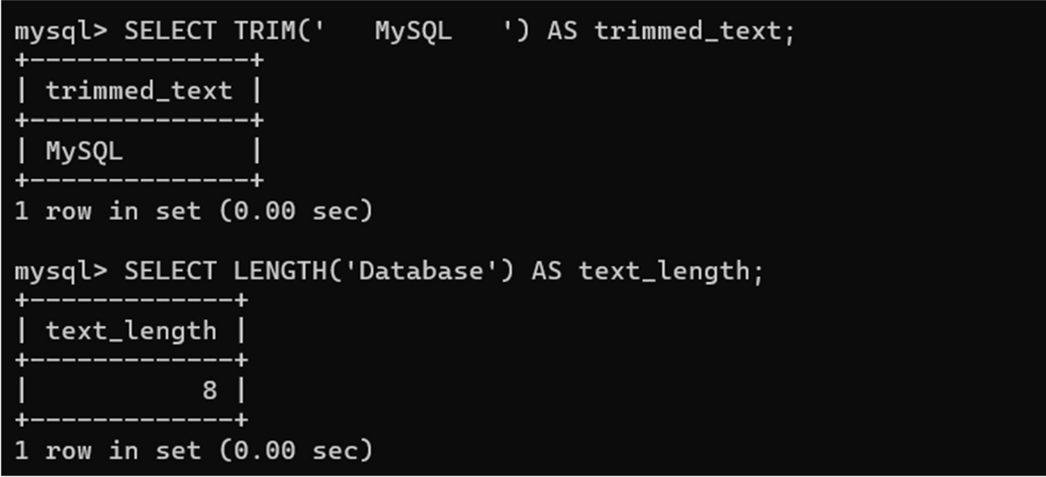
TRIM, LENGTH

